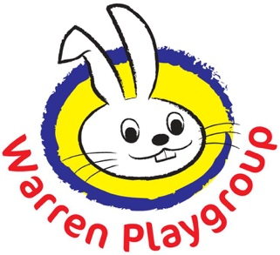

Dear Parents and Guardians,

Under the guidelines, every eligible child is entitled to access EYFE hours without any conditions attached.

You will still be invoiced termly this will show how many free entitlement hours your child is accessing and for any agreed additional hours your child attends beyond their funded entitlement. However, if your child attends only for the funded hours, you will receive additional agreed costs as voluntary such as, one off registration fee, a termly activities fee, and for enrichment activities like Yoga and Nature Makers, contribution to afternoon snack.

While these contributions are voluntary, we want to be transparent: we rely on them to continue offering the high-quality experiences and enrichment activities our children benefit from. Without sufficient support, the sustainability of the setting may be at risk.

Please note where activities or events are scheduled outside a child’s normal funded pattern then we are permitted to charge for them directly

If you can contribute we sincerely appreciate your support.

Thank you for your understanding and continued commitment to The Warren Playgroup.

