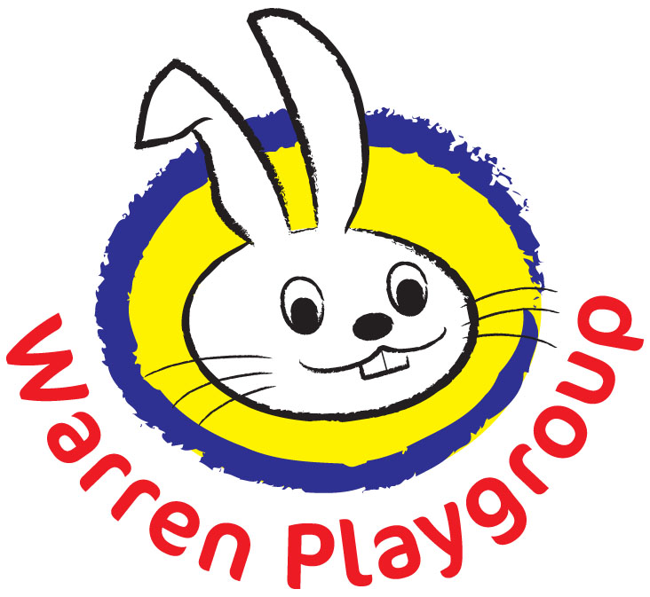 WARREN PLAYGROUP
REG CHARITY NO. 1005195

Name of child:

Please state below what voluntary contributions you are willing to pay.

One-off Registration Cost £35 YES/NO

Termly Activities Cost £35 YES/NO

Yoga Sessions £2.50 per session (up to 6 per term) YES/NO

Nature Makers Sessions £3 per session (up to 4 sessions per term) YES/NO

Afternoon snack Cost based on 30p per day (this is calculated on the days your child is due to attend during the term and a termly amount will be added to your invoice). Yes/No. Alternatively I will provide my child’s own afternoon snack Yes/NO

If you would like to organise a payment plan, please state below: -

2 equal payments half termly Yes/No

Weekly payments divided between the term Yes/No

Monthly payments over the term. Yes/No

If for any reason you take your child away from playgroup during the term these payments are still liable.
Signed…………………………………………………………………parent/guardian. Date………………………………………………

2 copies given to parents please keep one copy and return one copy.

